**POINTERS (PART 1 BASICS)**

**LAB # 8**



**Spring 2022**

**CSE102L Computer Programming Lab**

Submitted by: **Ali Asghar**

Registration No. : **21PWCSE2059**

Class Section: **C**

“On my honor, as student of University of Engineering and Technology, I have neither given nor received unauthorized assistance on this academic work.”

Student Signature: ______________

Submitted to:

**Engr. Abdullah Hamid**

July 4, 2022

Department of Computer Systems Engineering

University of Engineering and Technology, Peshawar

**Lab Objective(s)**

* To understand the programming of recursive functions and overloading functions
* To understand function programming, its types and function-call

**TASK # 1:**

**Title:**

Write a C++ program where you take two values in two……………..you must you use only one pointer.

**CODE SCREENSHOTS:**

Here is the screenshot of the code.

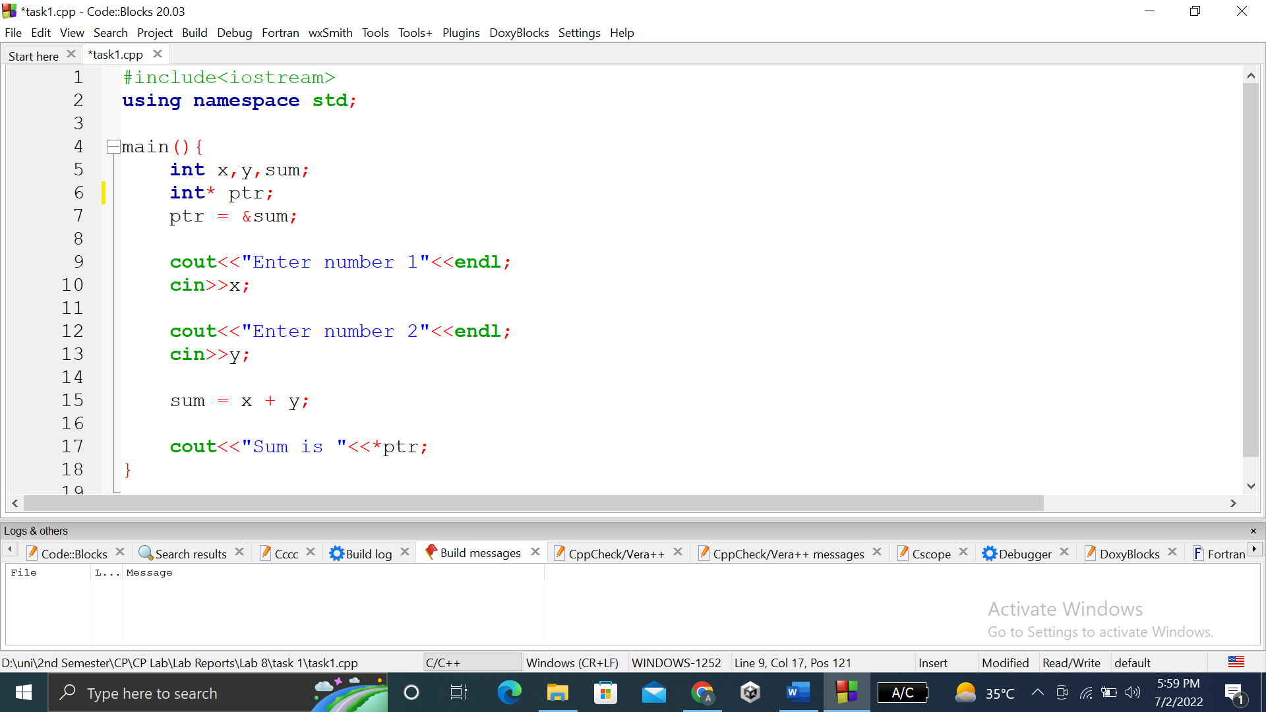

### **OUTPUT (COMPILATION, DEBUGGING & TESTING):**

Here is the screenshot of the output of above code.

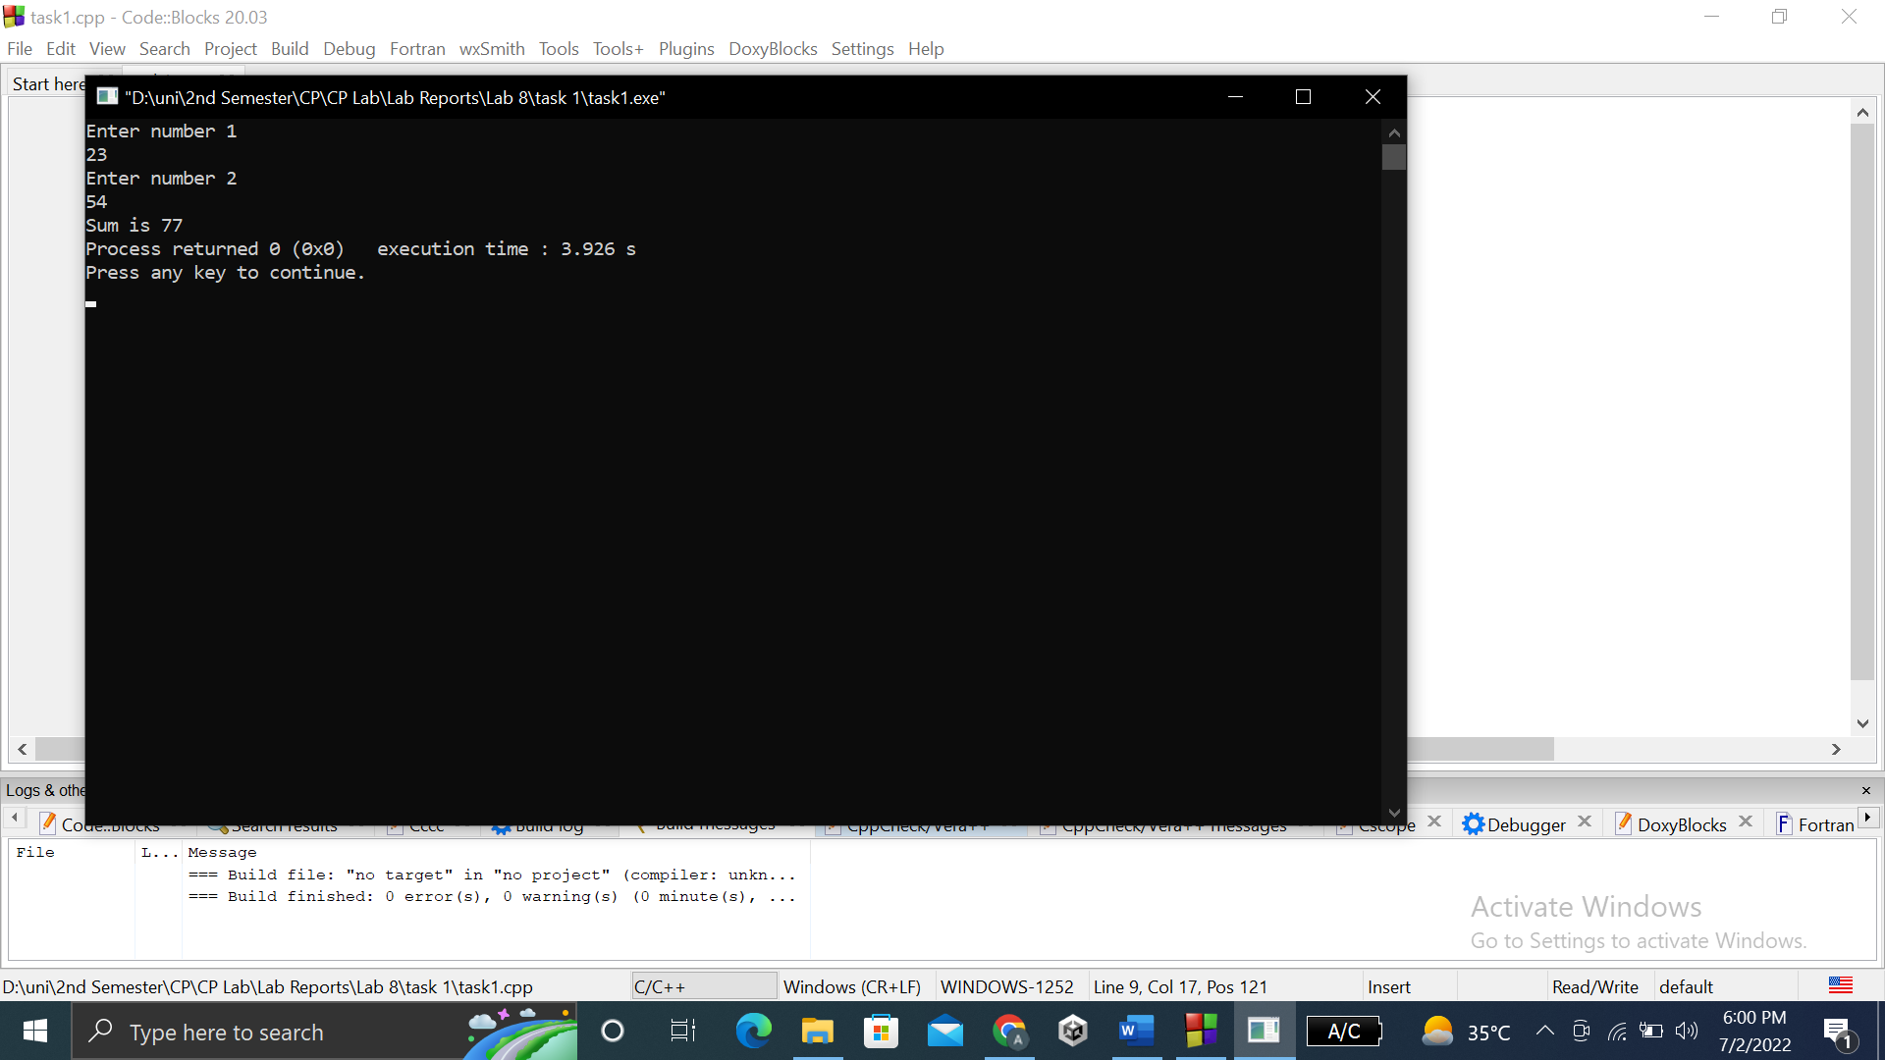

**TASK # 2:**

**Title:**

Write a C++ program where you take two values from user in two variables, swaps the values of the variables using pointers.

**CODE SCREENSHOTS:**

Here are the screenshots of the code.

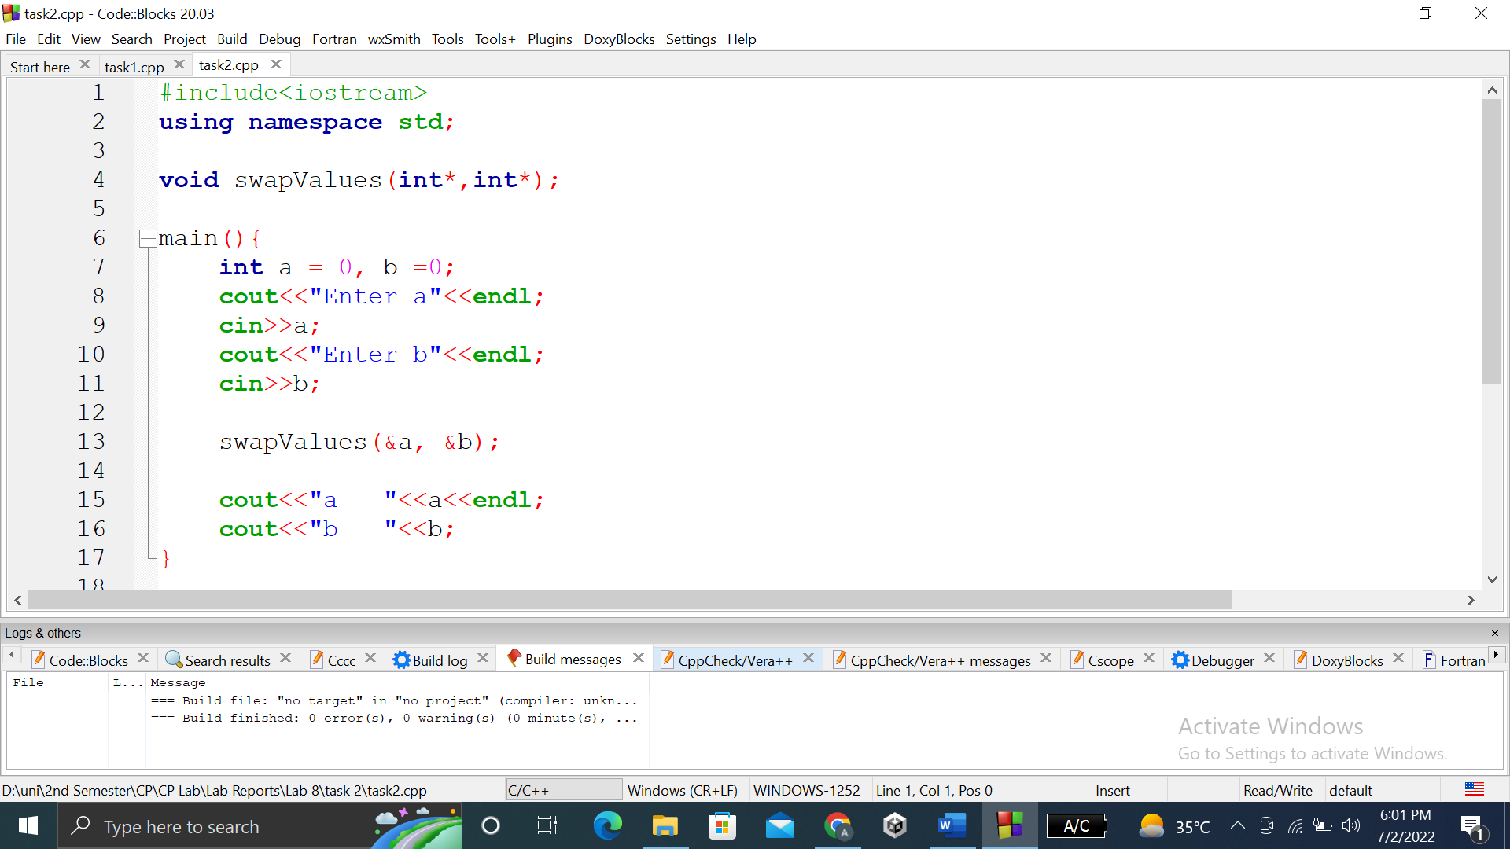

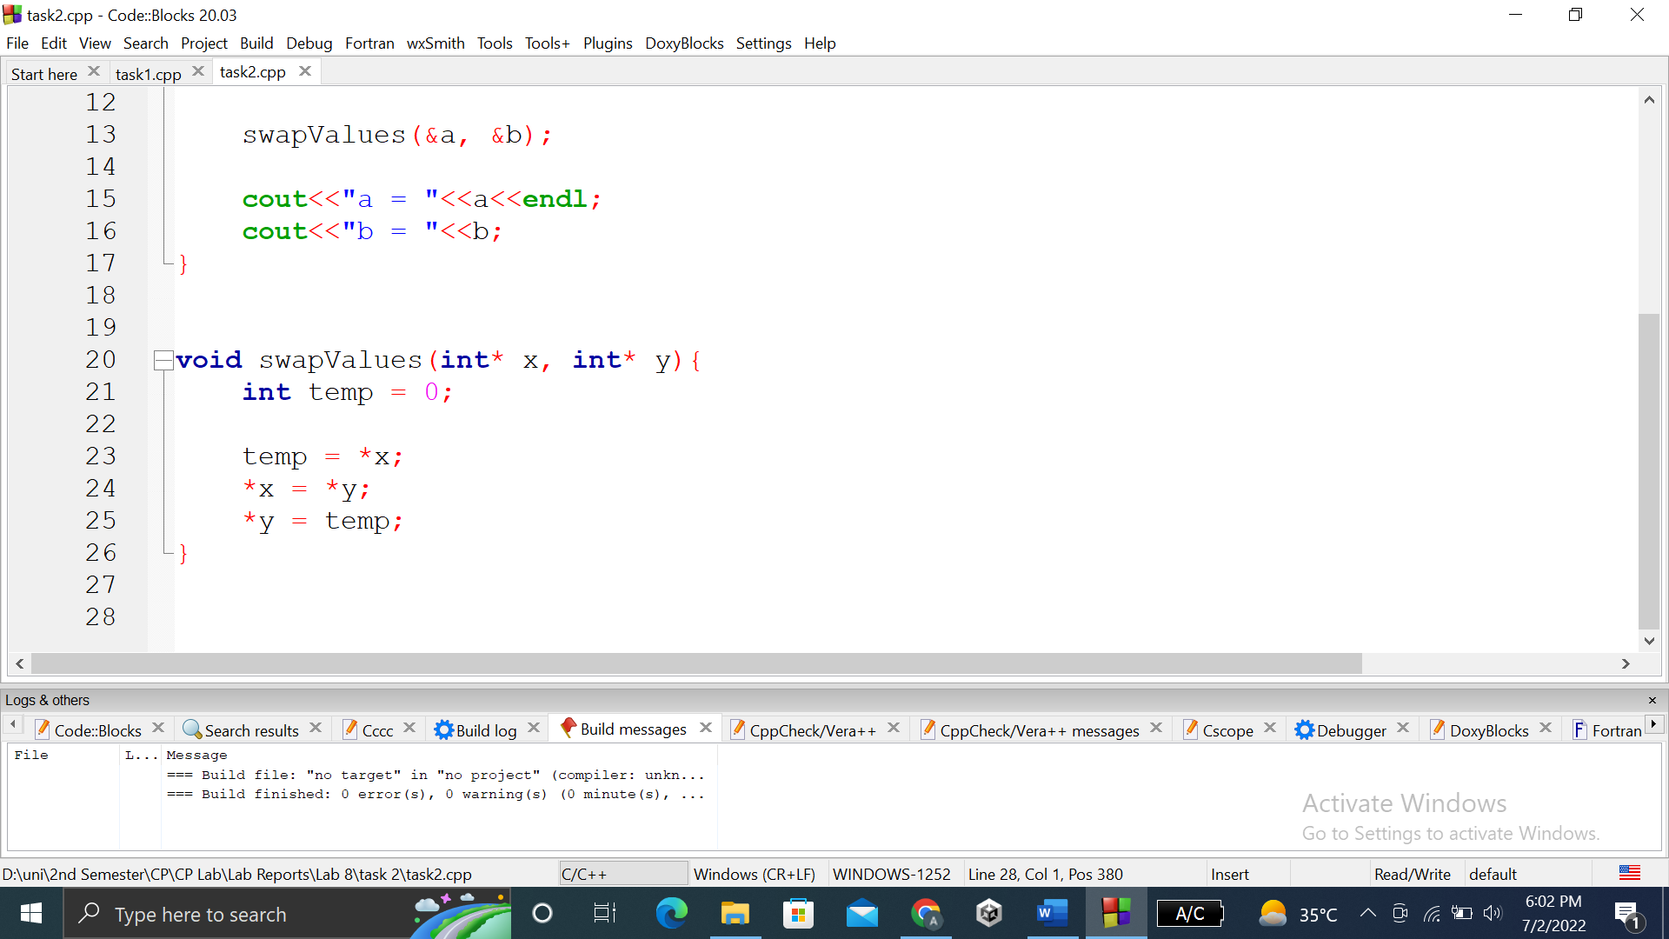

### **OUTPUT (COMPILATION, DEBUGGING & TESTING):**

Here are the screenshots of the output of above code.

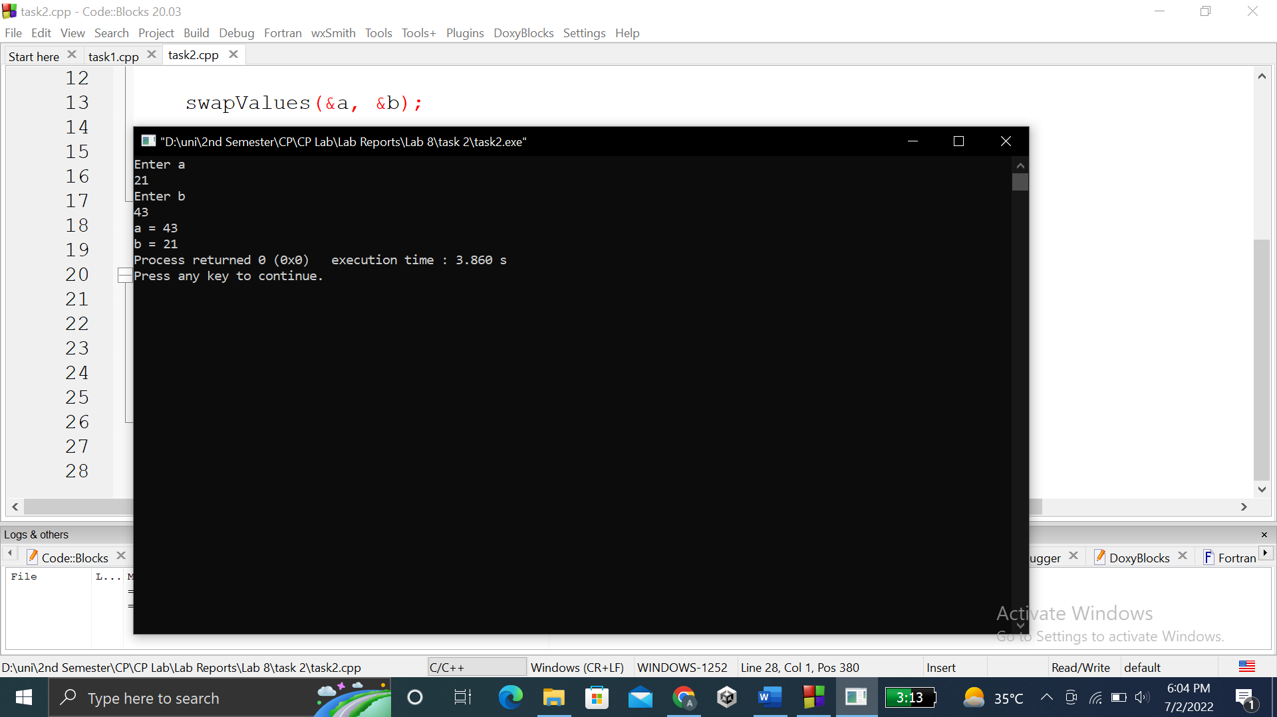

**TASK # 3:**

**Title:**

Write a C++ program where you take a value in a variable from use increment that value by 5 using a pointer in a for loop and display its value using pointer.

**CODE SCREENSHOTS:**

Here is the screenshot of the code.

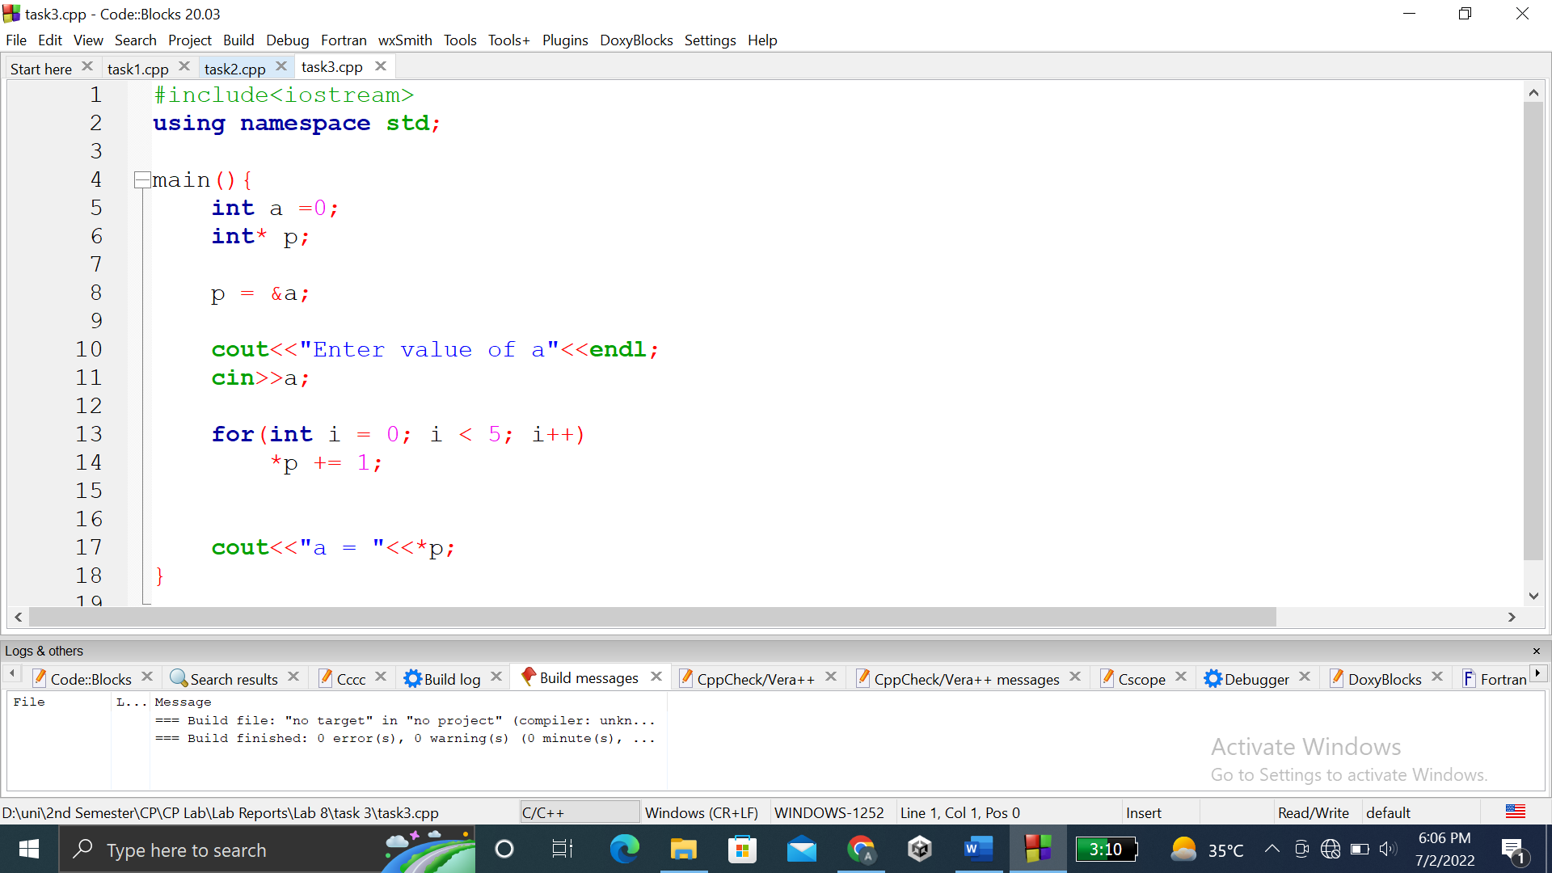

### **OUTPUT (COMPILATION, DEBUGGING & TESTING):**

Here is the screenshot of the output of above code.

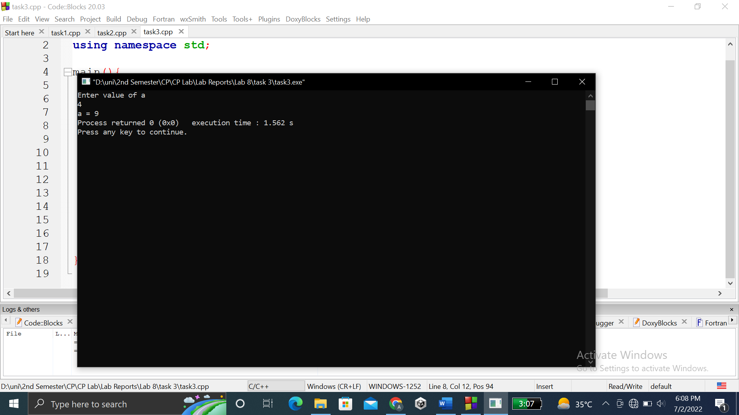

**TASK # 4:**

**Title:**

Write a C++ program where you take your first name from user in a string variable…..And then display both using a single pointer.

**CODE SCREENSHOTS:**

Here are the screenshots of the code.

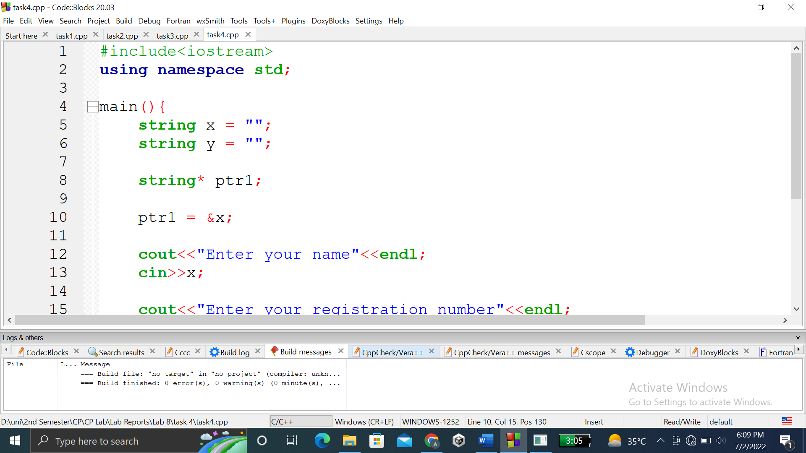

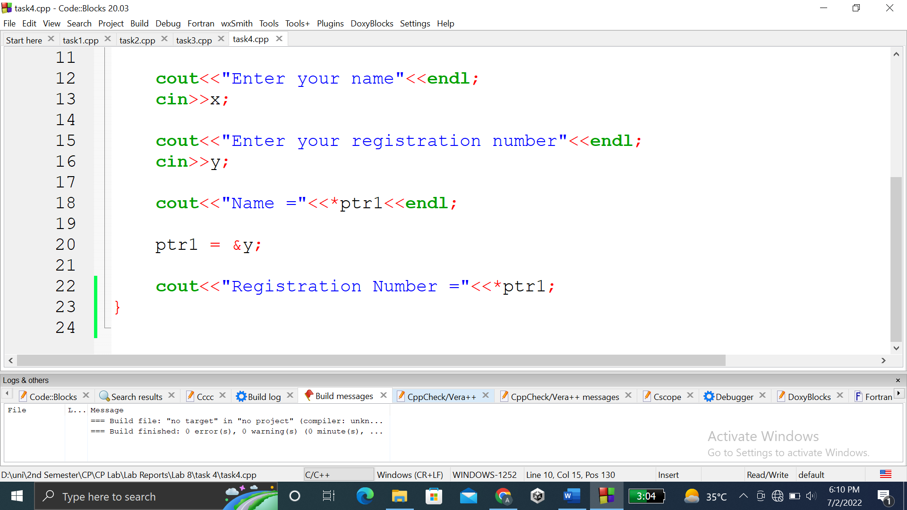

### **OUTPUT (COMPILATION, DEBUGGING & TESTING):**

Here is the screenshot of the output of above code.

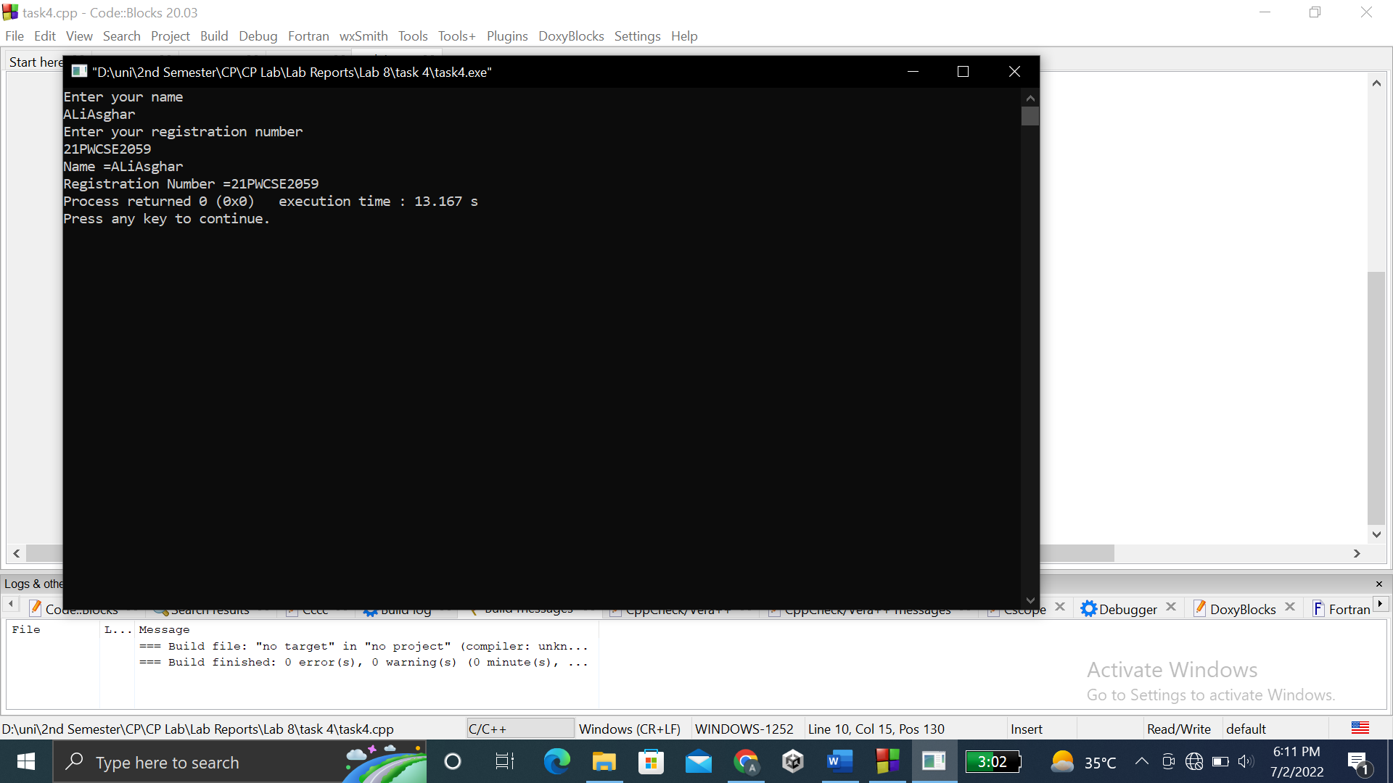

**TASK # 5:**

**Title:**

Display 1 to n numbers using pointer, user must enter the n.

**CODE SCREENSHOTS:**

Here is the screenshot of the code.

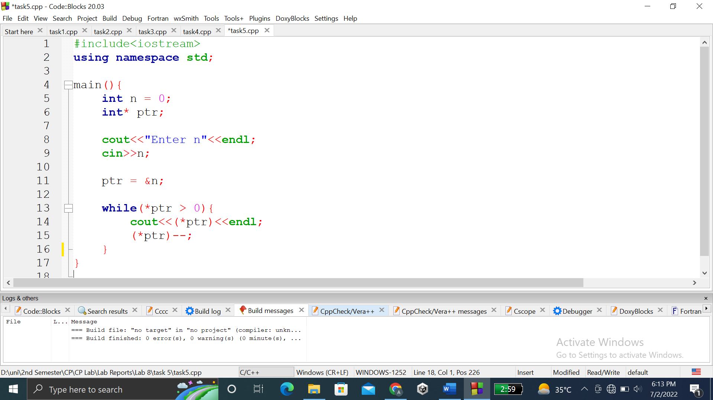

### **OUTPUT (COMPILATION, DEBUGGING & TESTING):**

Here is the screenshot of the output of above code.

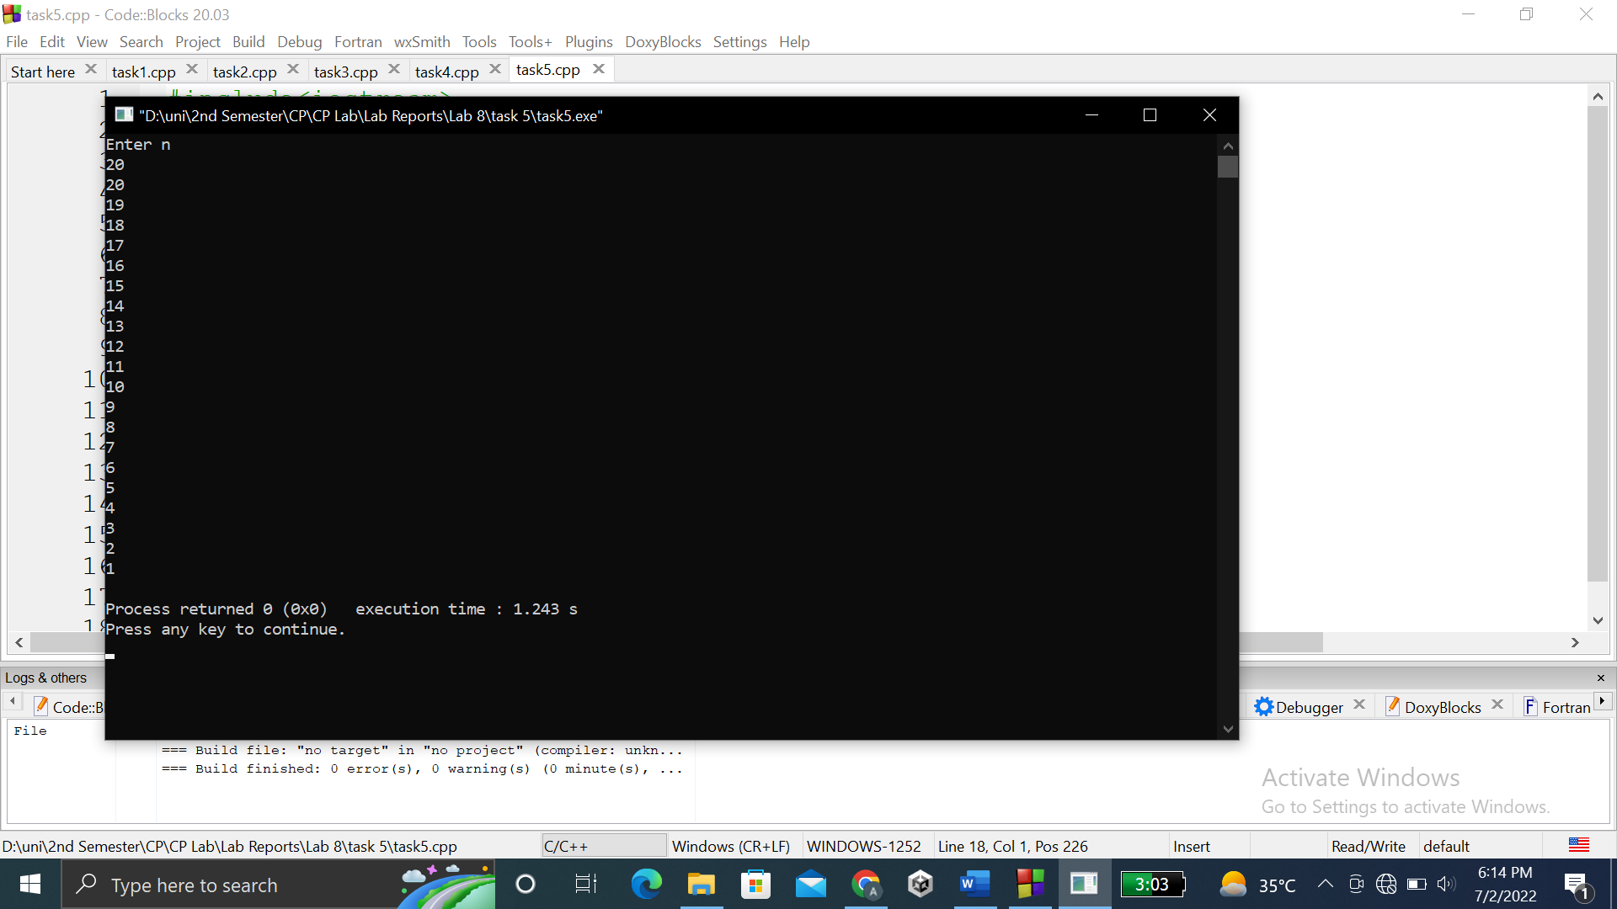

**TASK # 6:**

**Title:**

Add even numbers from 1 to n using pointers user must enter n.

**CODE SCREENSHOTS:**

Here are the screenshots of the code.

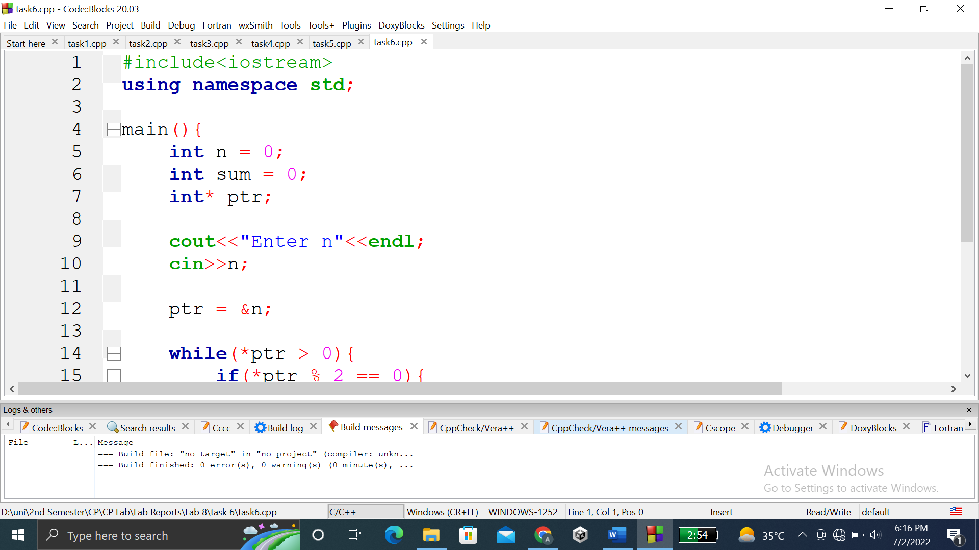

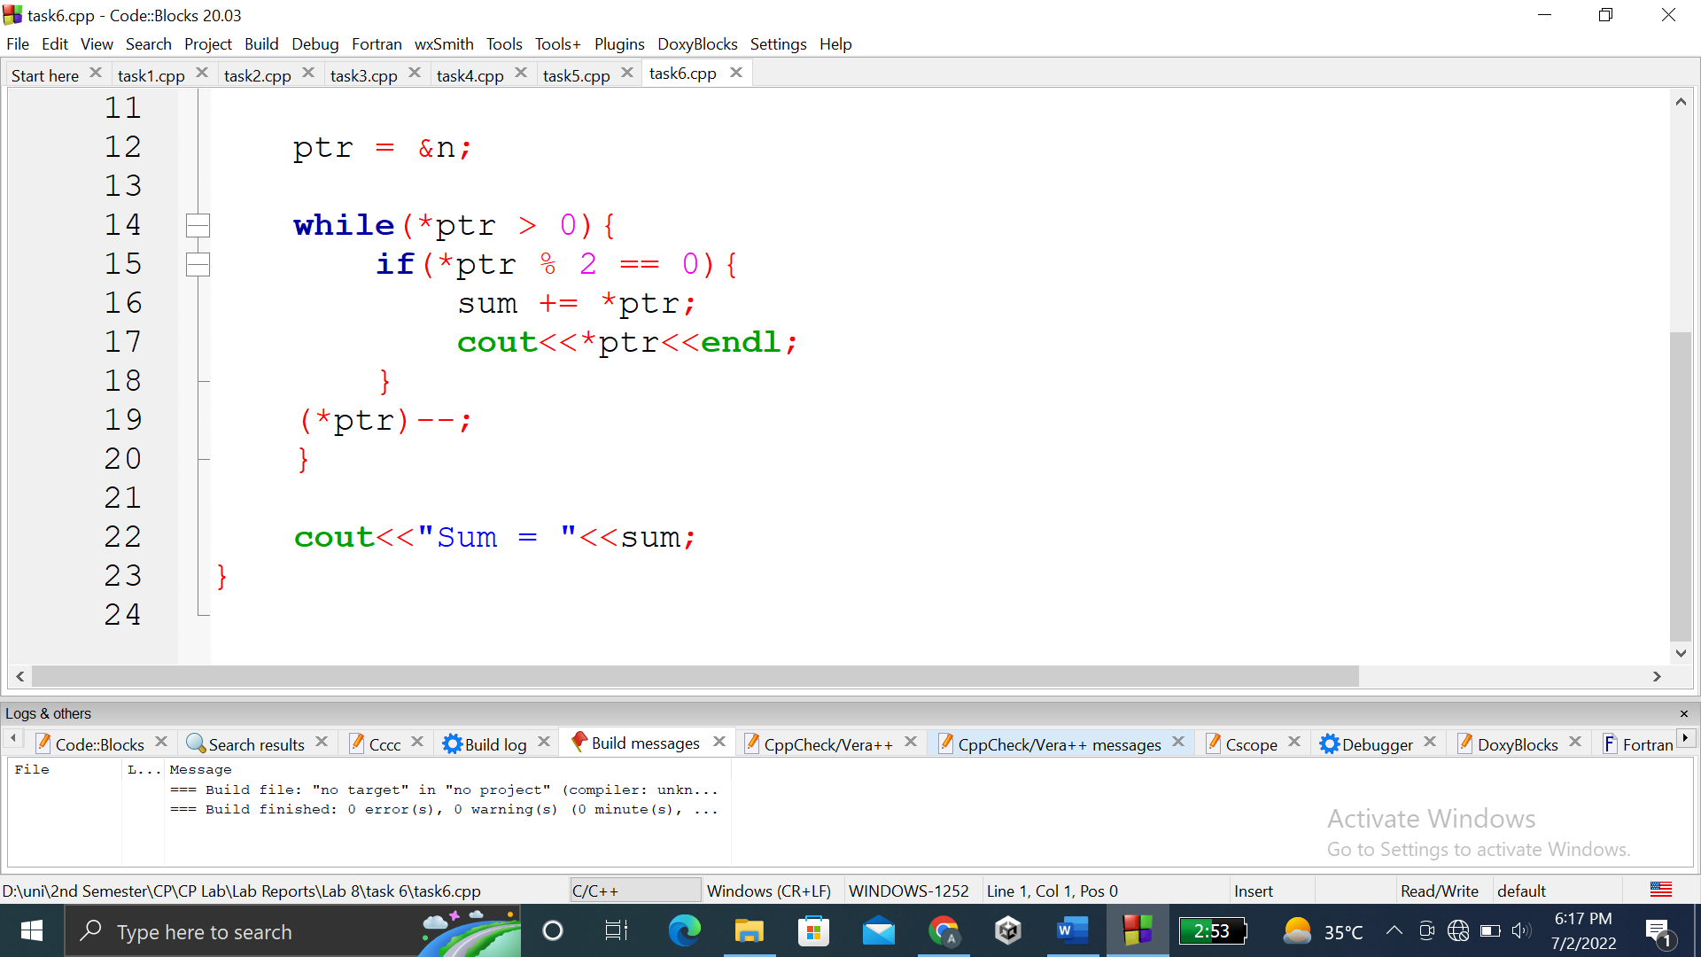

### **OUTPUT (COMPILATION, DEBUGGING & TESTING):**

Here is the screenshot of the output of above code.

